Install SAM CLI

<https://docs.aws.amazon.com/serverless-application-model/latest/developerguide/sam-cli-install-linux-alt.html>

Make SURE template.yaml field should be outside app.py where it is located.

# Create an s3 bucket

aws s3 mb s3://demo-user-code-sam

## package cloudformation

aws cloudformation package  --s3-bucket demo-user-code-sam --template-file template.yaml --output-template-file gen/template-generated.yaml

## deploy

aws cloudformation deploy --template-file gen/template-generated.yaml --stack-name hello-world-sam --capabilities CAPABILITY_IAM

output

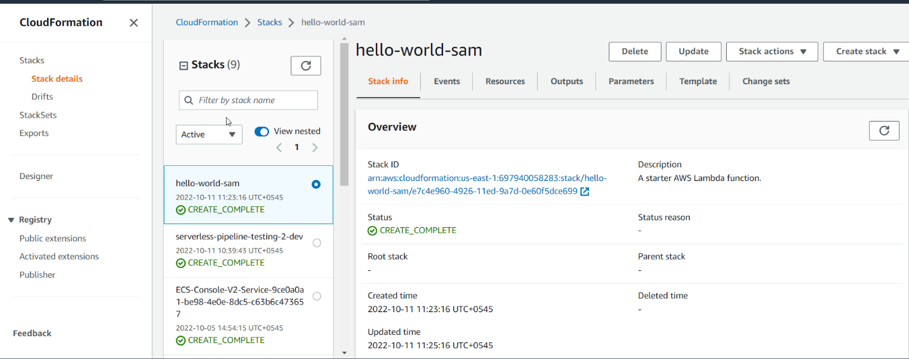

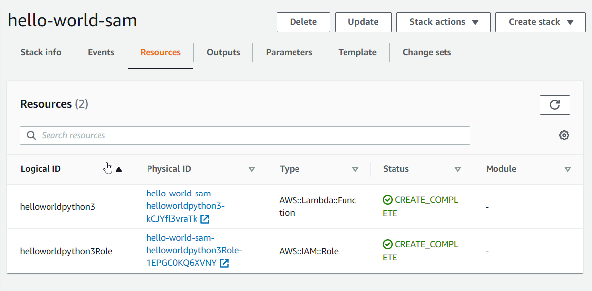

Lambda function

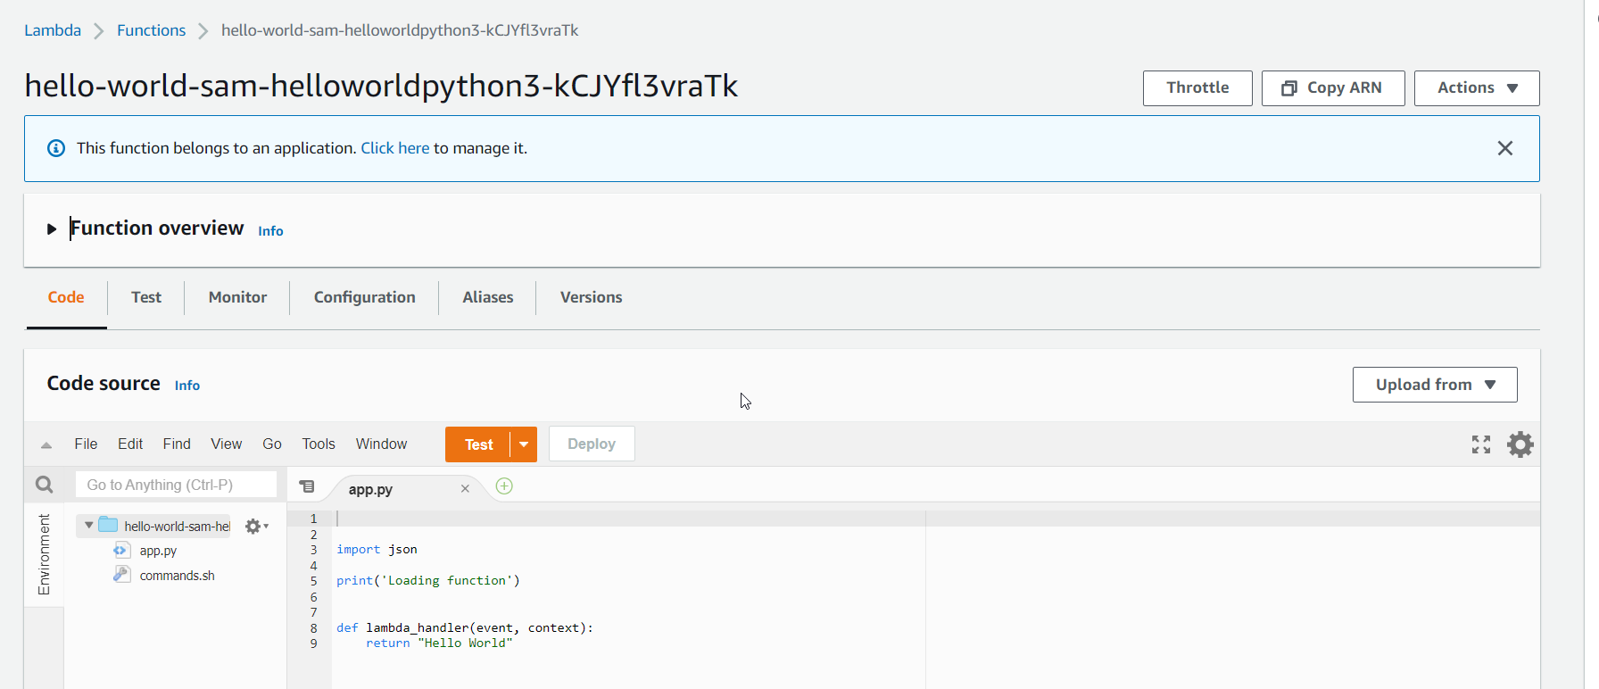

You can test

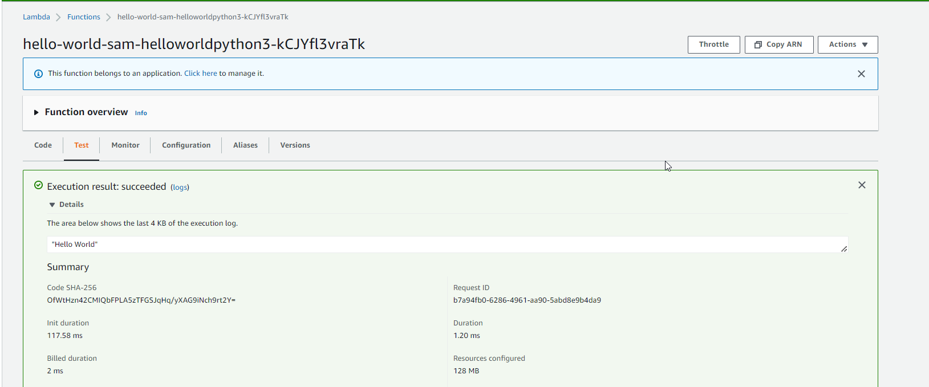

<https://github.com/amazon-archives/serverless-app-examples/tree/master/python/microservice-http-endpoint-python3>

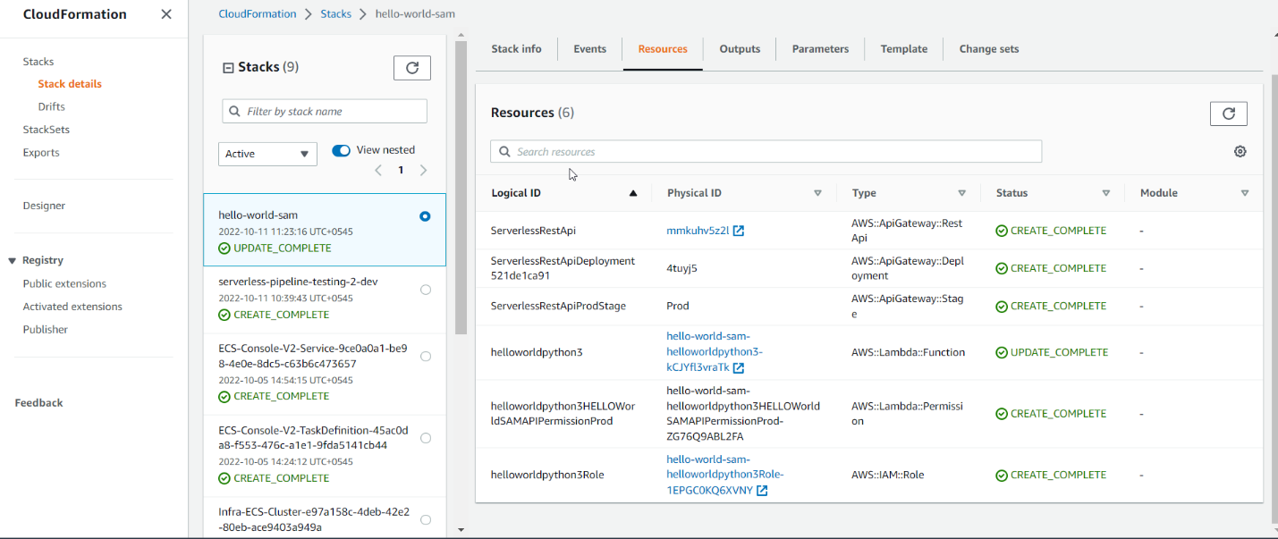

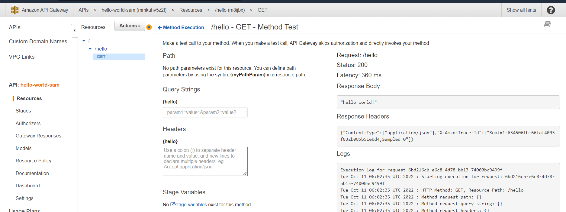

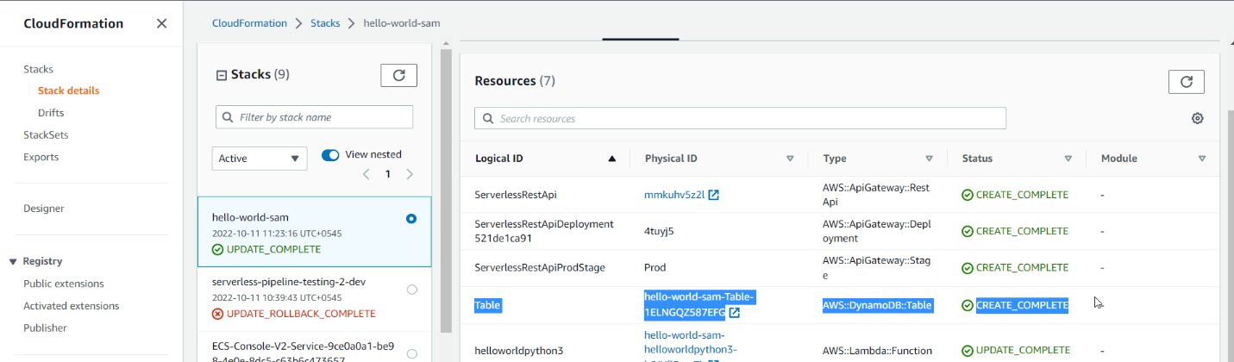

Go to dynamodb and add items

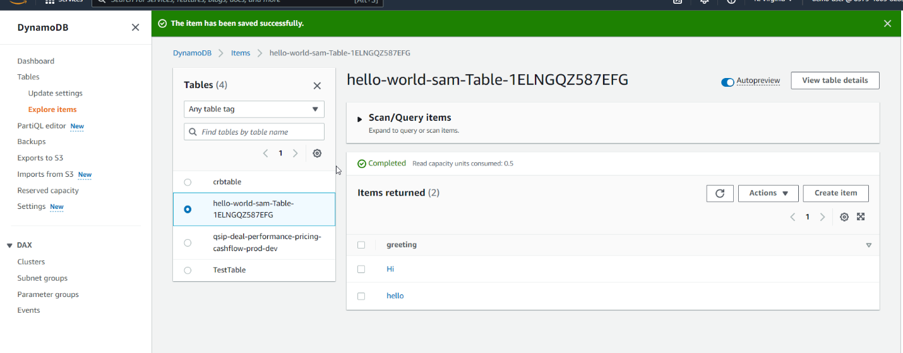

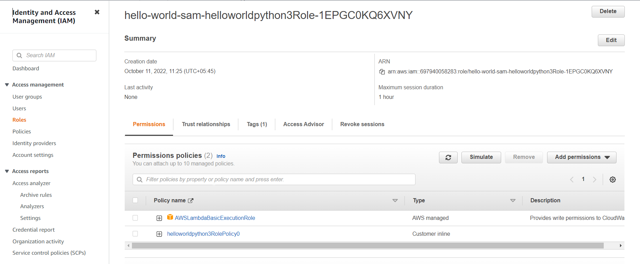

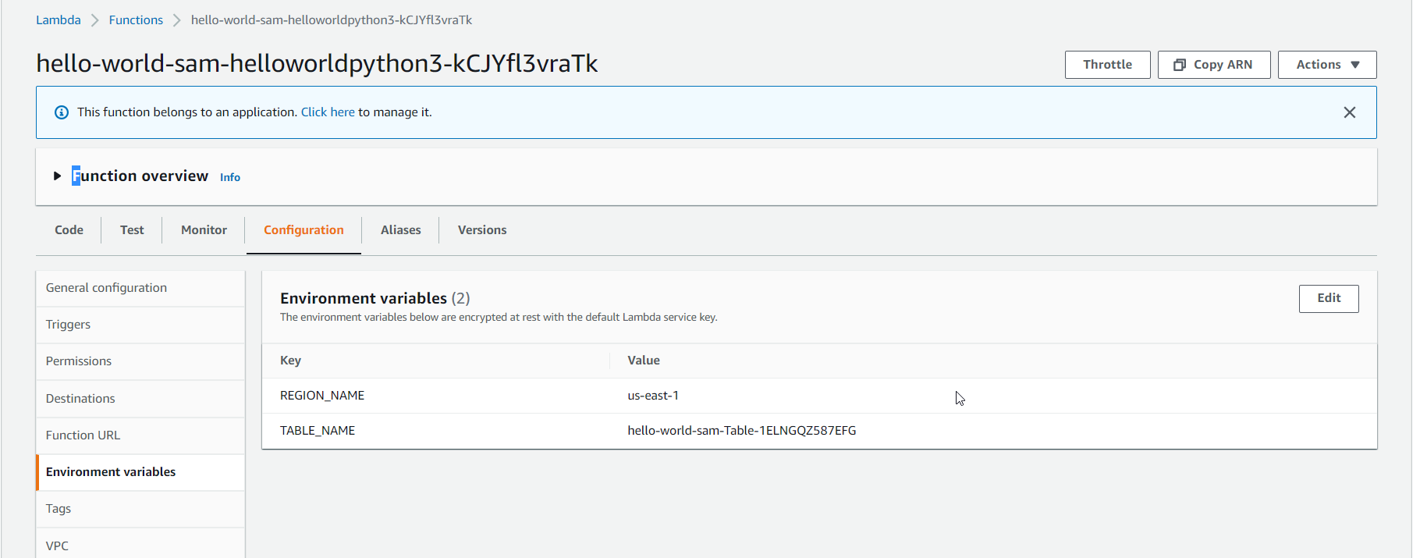

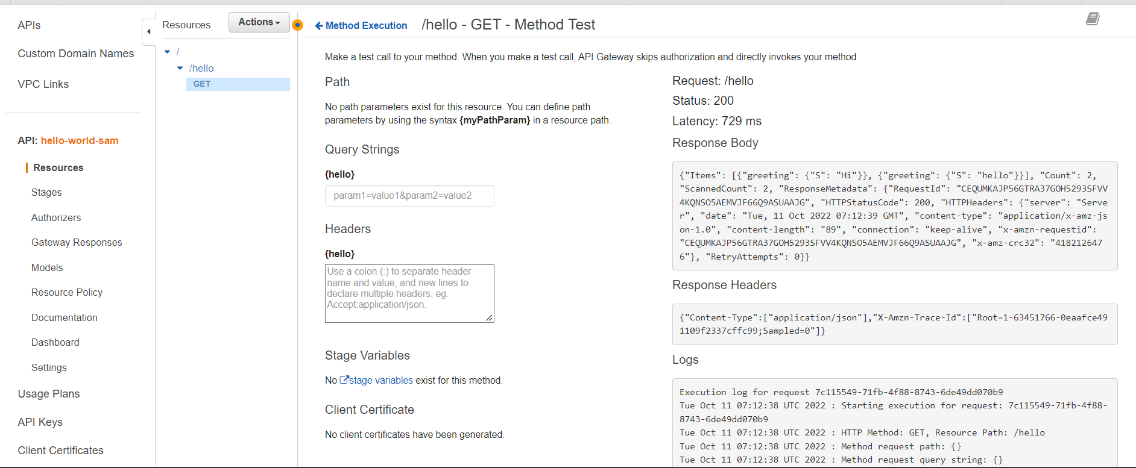

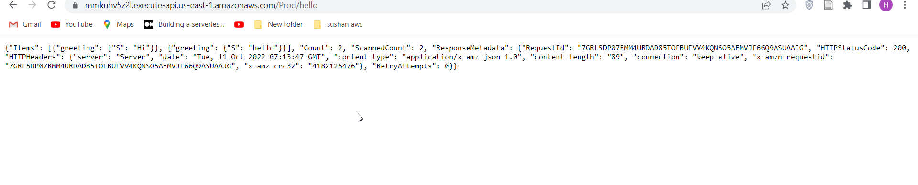

**SAM WITH CODE DEPLOY**

From: https://docs.aws.amazon.com/serverless-application-model/latest/developerguide/serverless-getting-started-hello-world.html

**# Step 1 - Download a sample application**

sam init --runtime python3.9

**# Step 2 - Build your application**

cd sam-app

sam build

**# Step 3 - Package your application**

sam deploy --guided

      AutoPublishAlias: live

#Codedepoly.yaml

      DeploymentPreference:

       Type: Canary10Percent10Minutes

[**https://learn.microsoft.com/en-us/windows/win32/fileio/maximum-file-path-limitation?tabs=powershell#enable-long-paths-in-windows-10-version-1607-and-later**](https://learn.microsoft.com/en-us/windows/win32/fileio/maximum-file-path-limitation?tabs=powershell#enable-long-paths-in-windows-10-version-1607-and-later)

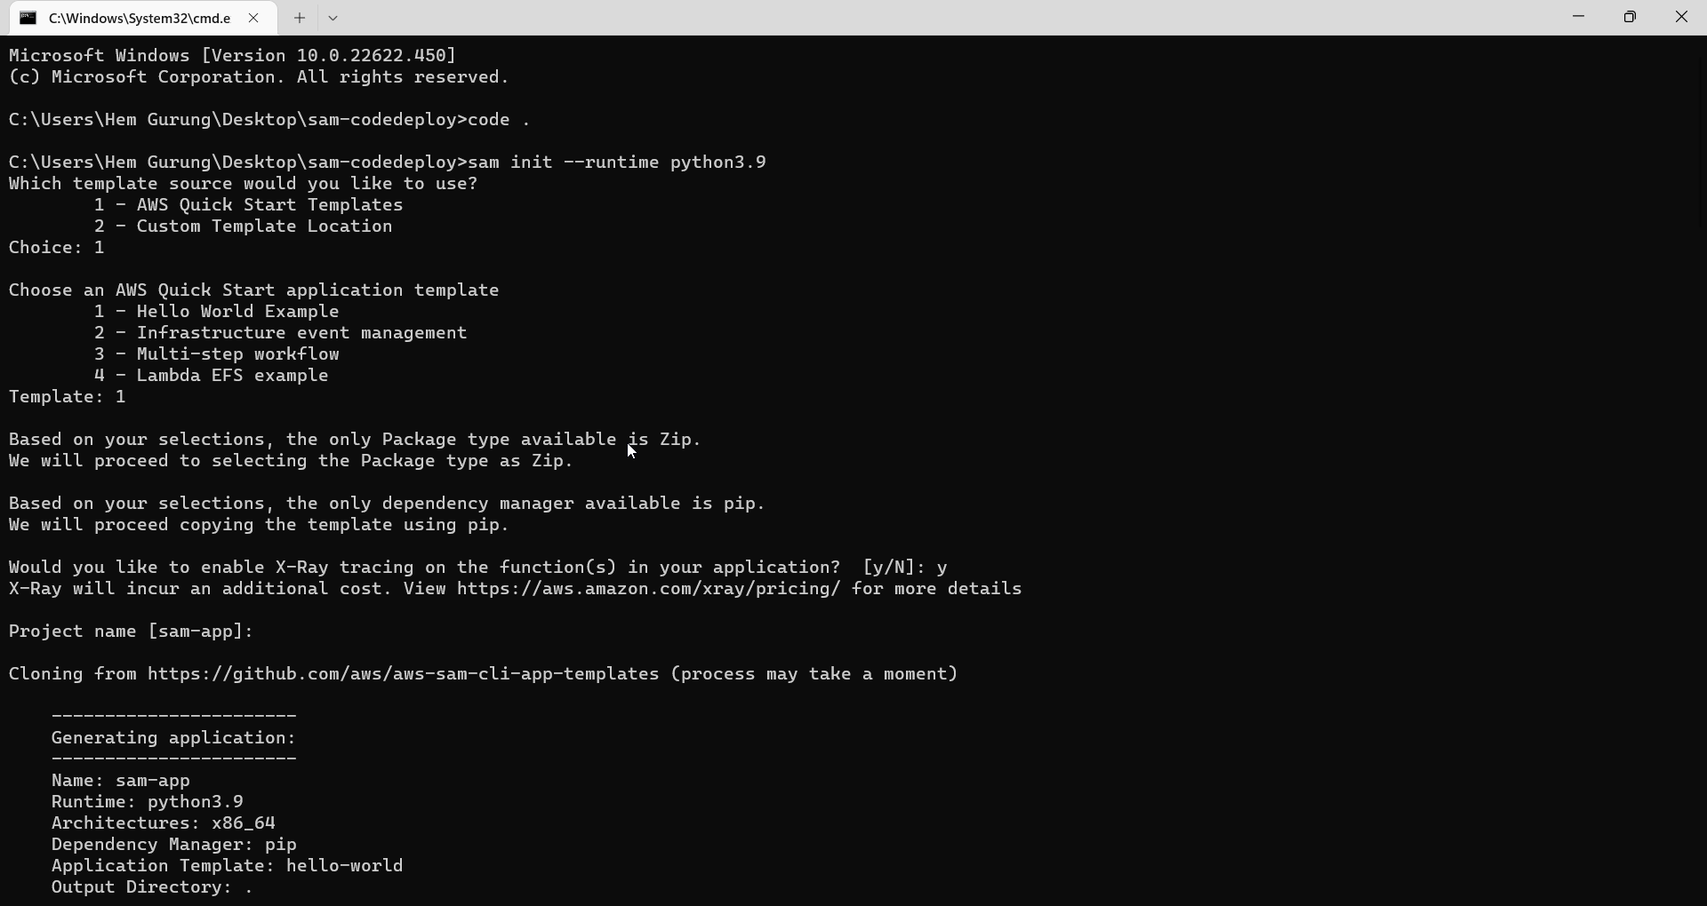

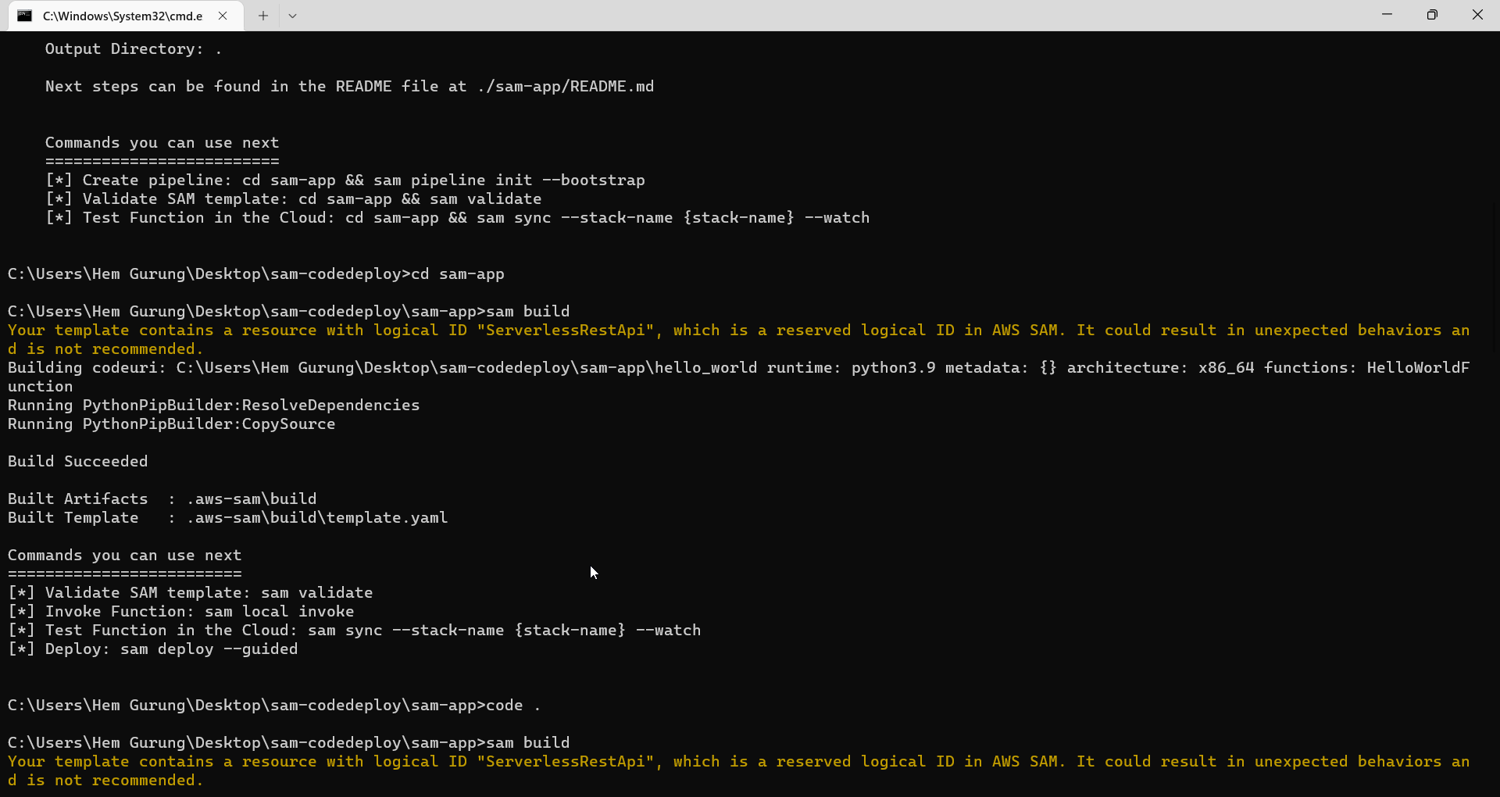

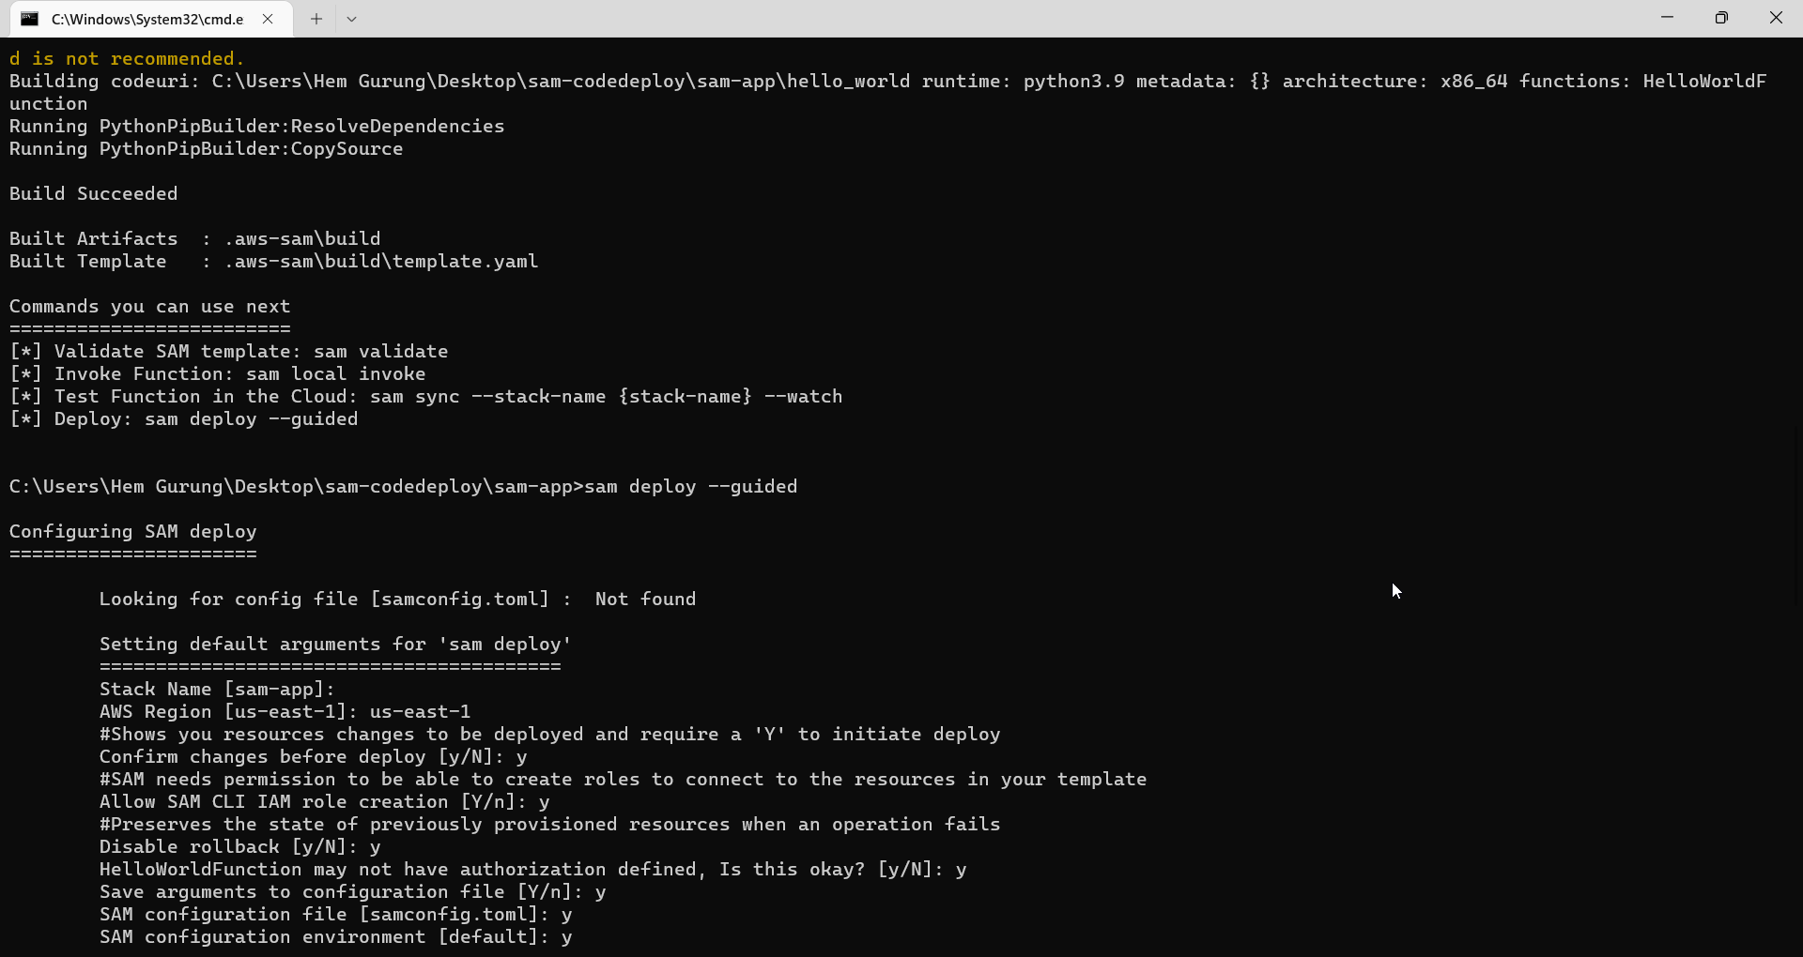

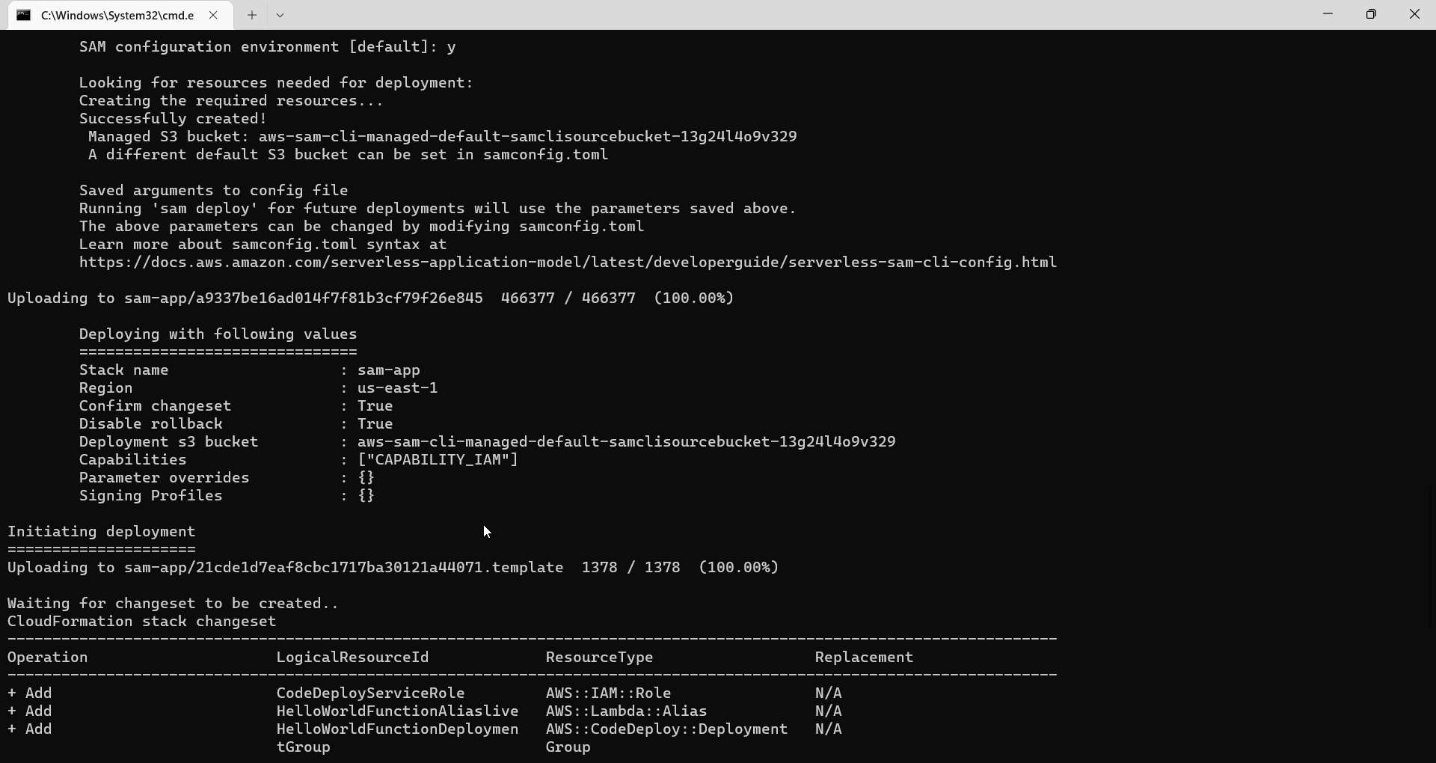

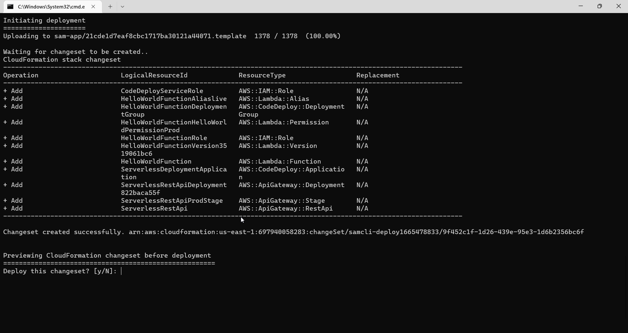

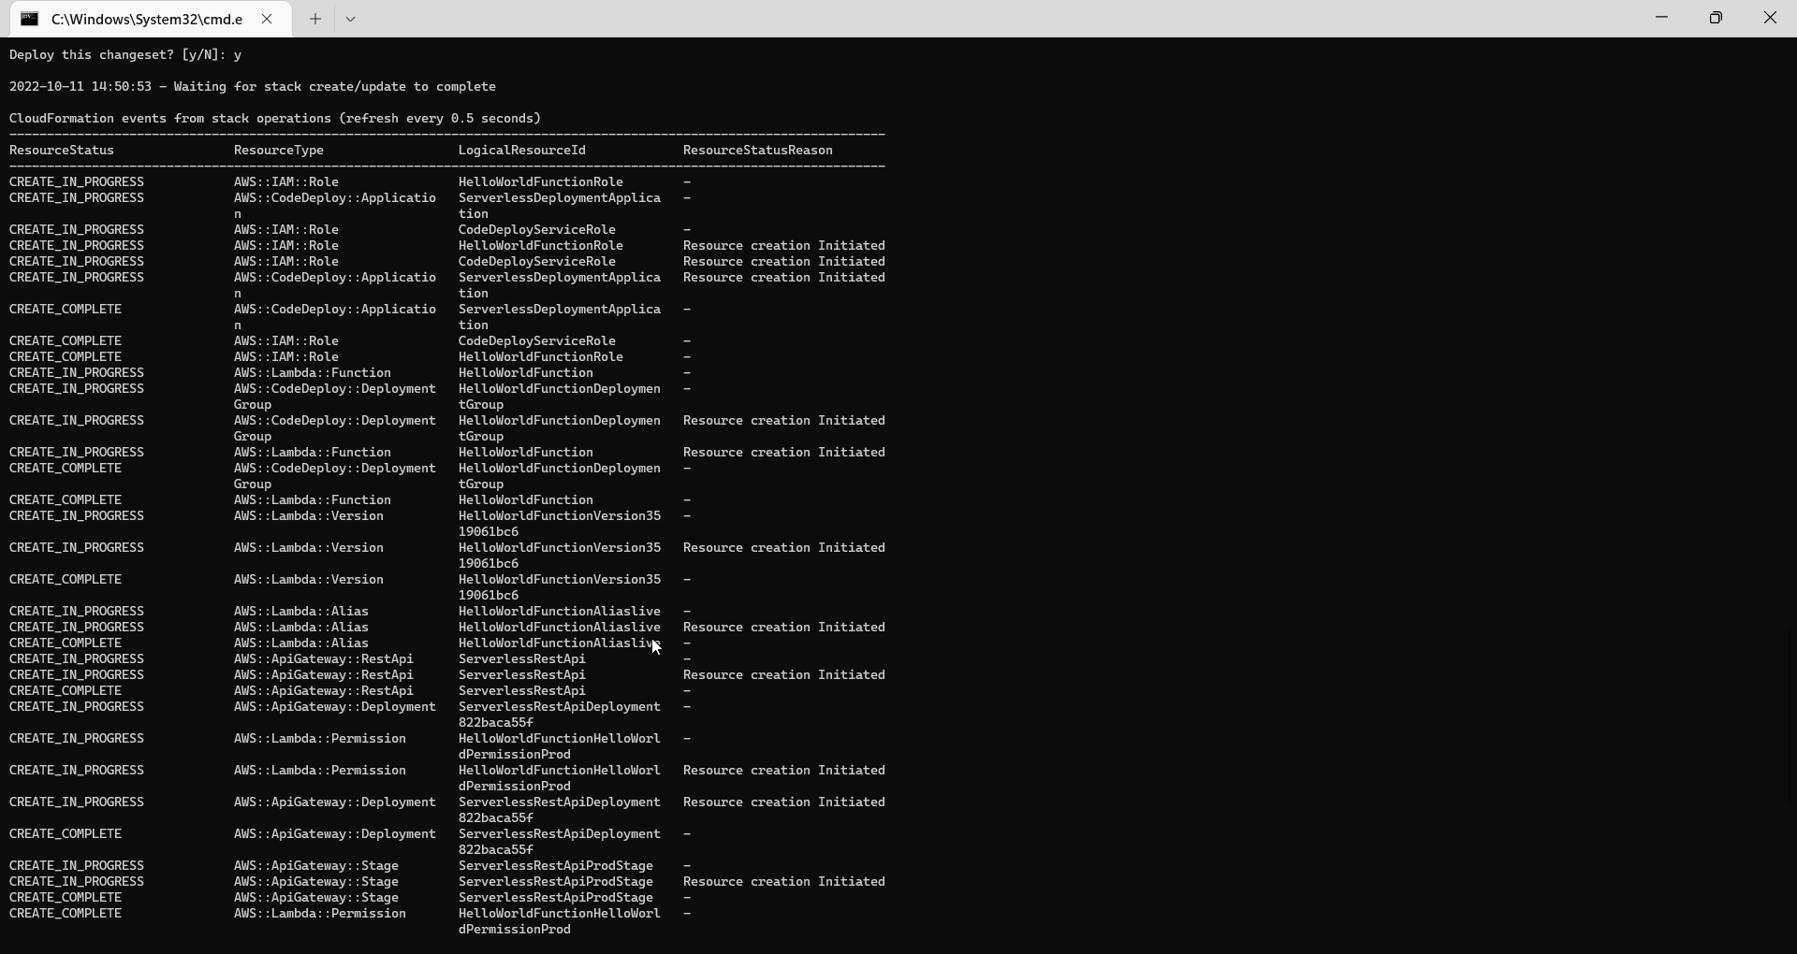

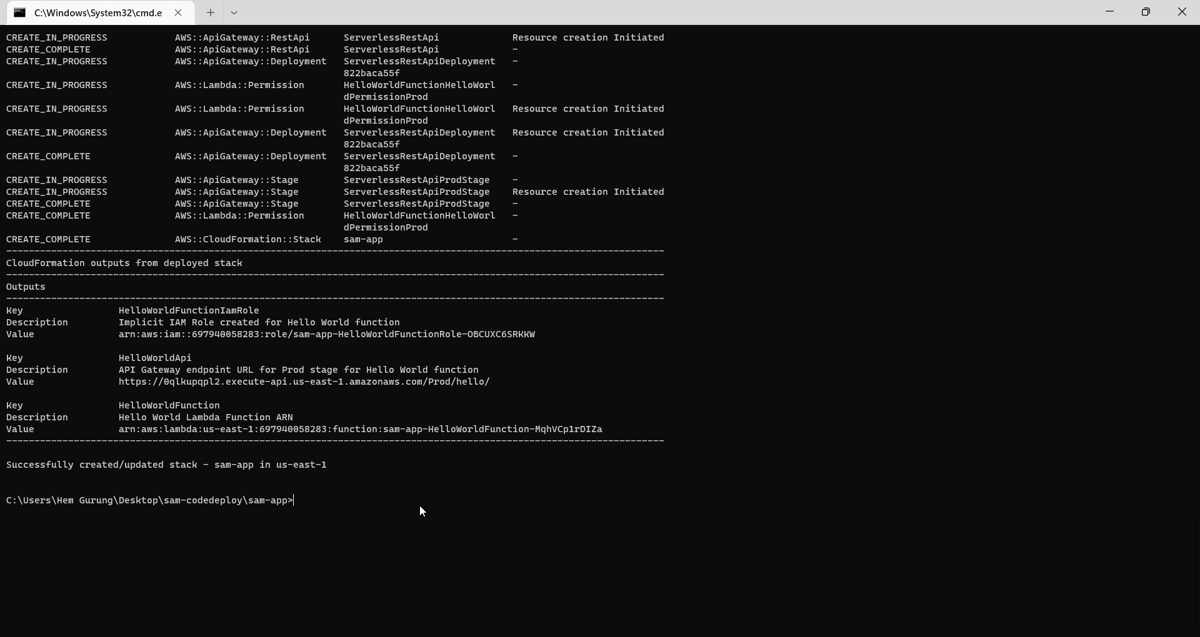

Go to lambda function >> application

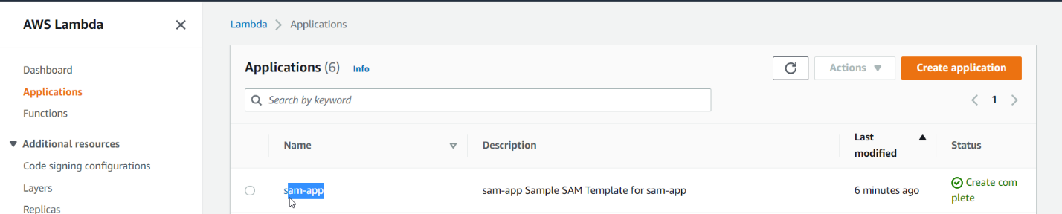

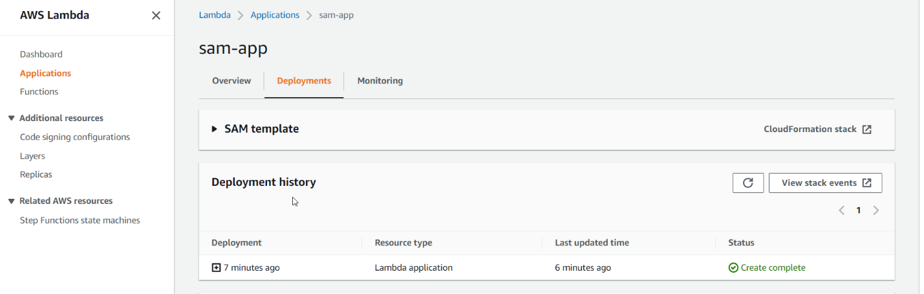

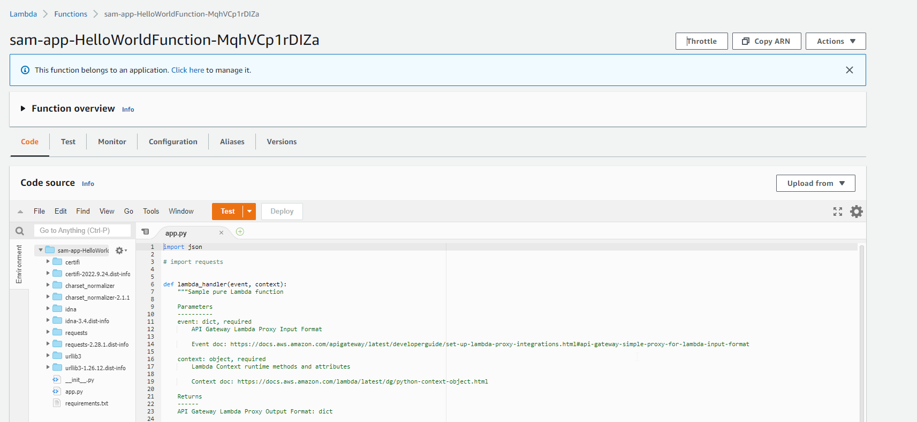

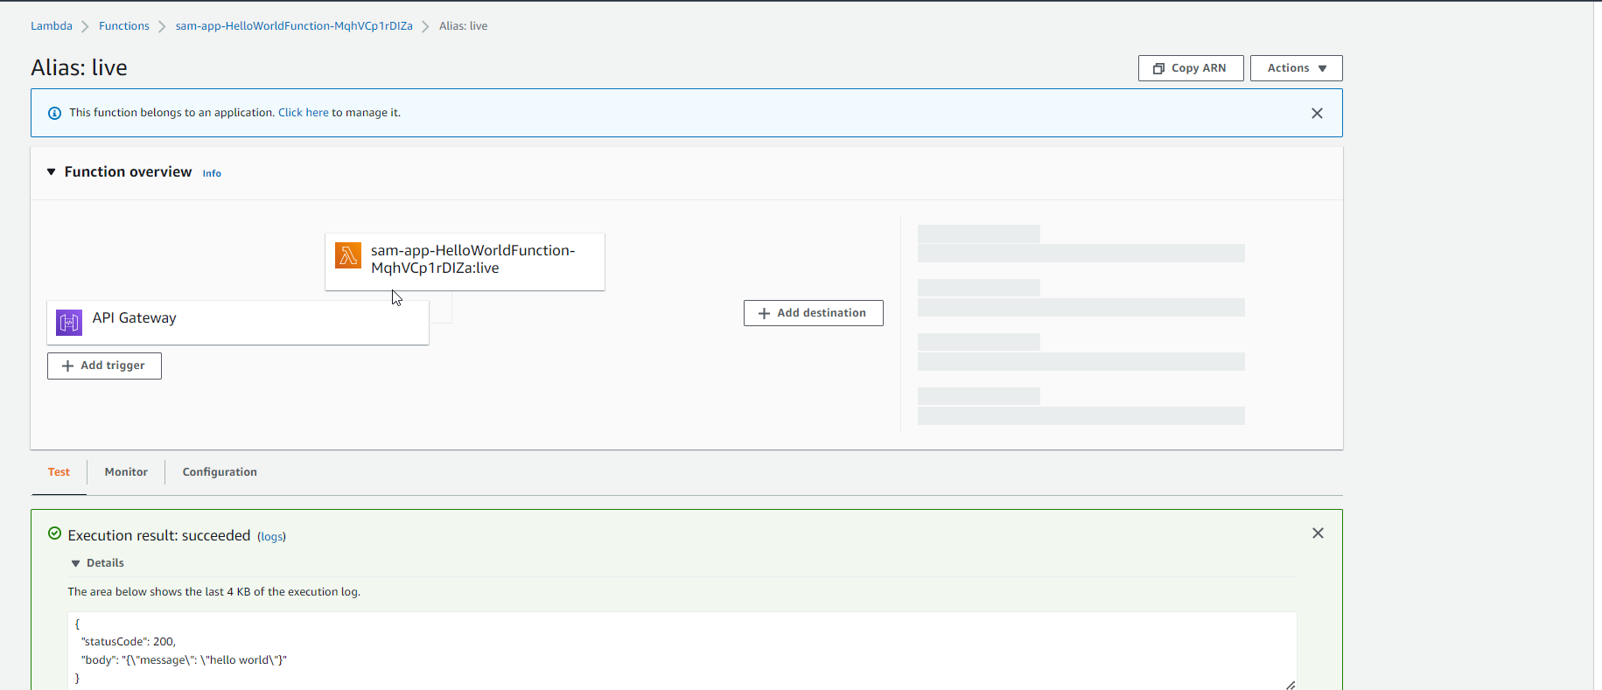

Refresh lambda alias

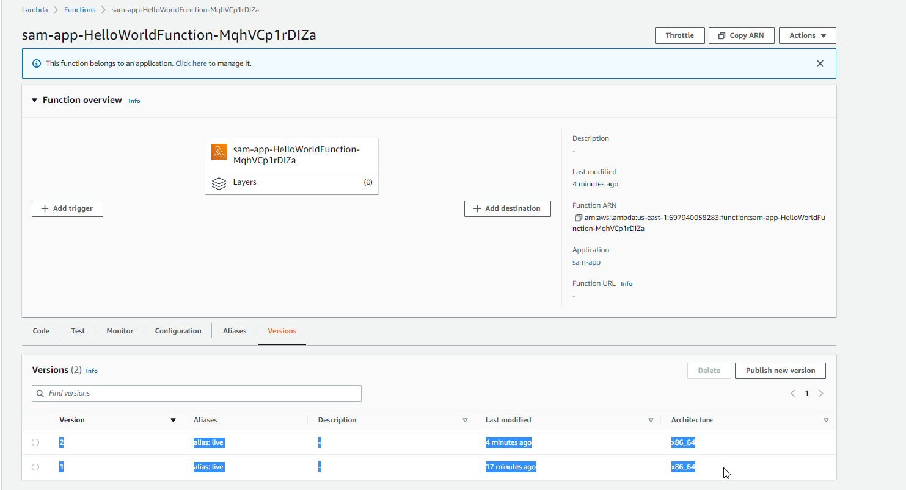

Go to code deploy

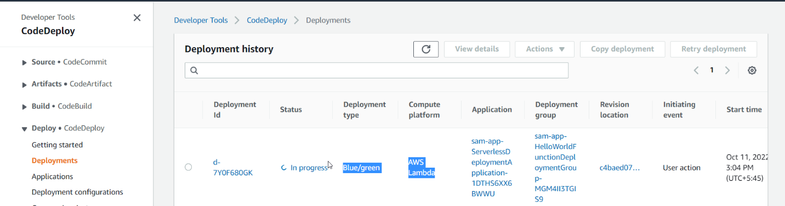

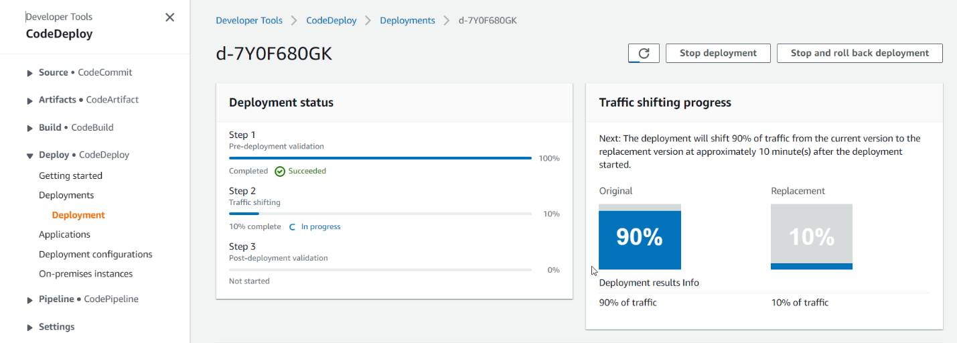

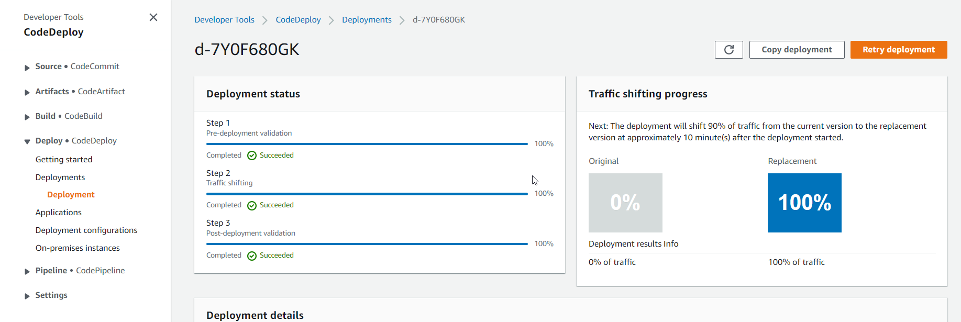S

**Serverless Application Repository**

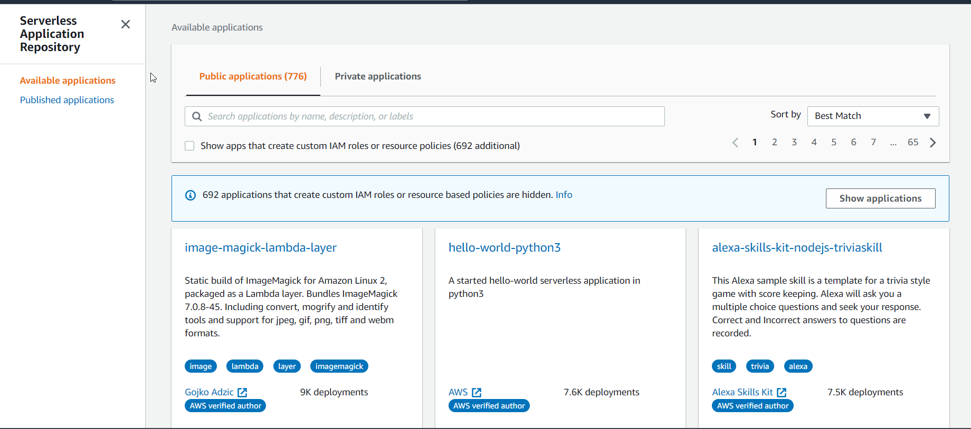

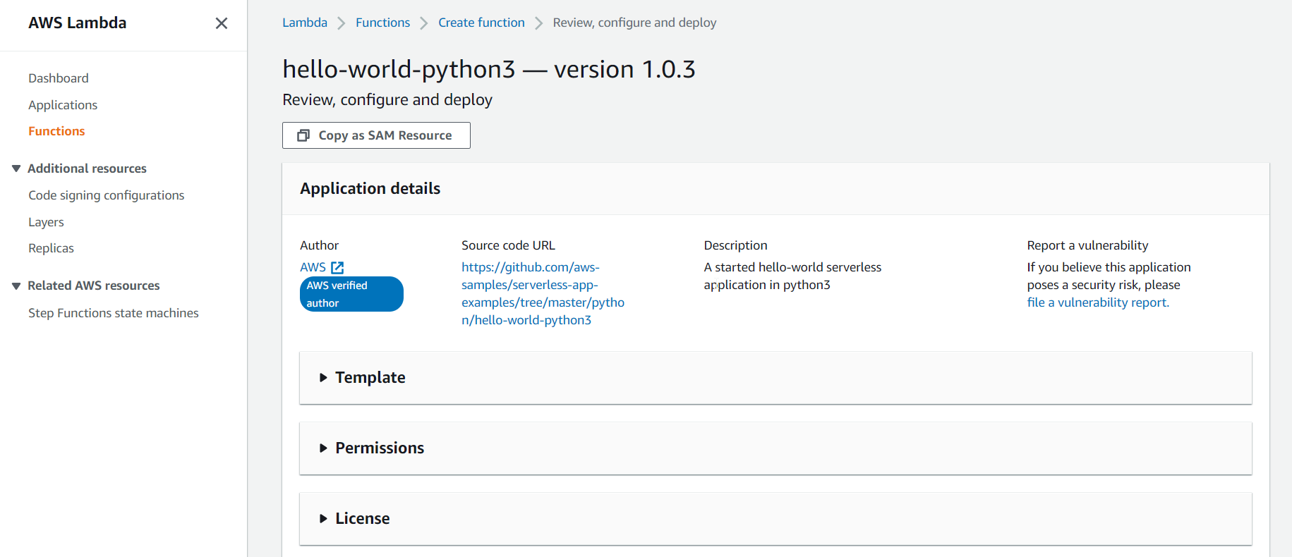

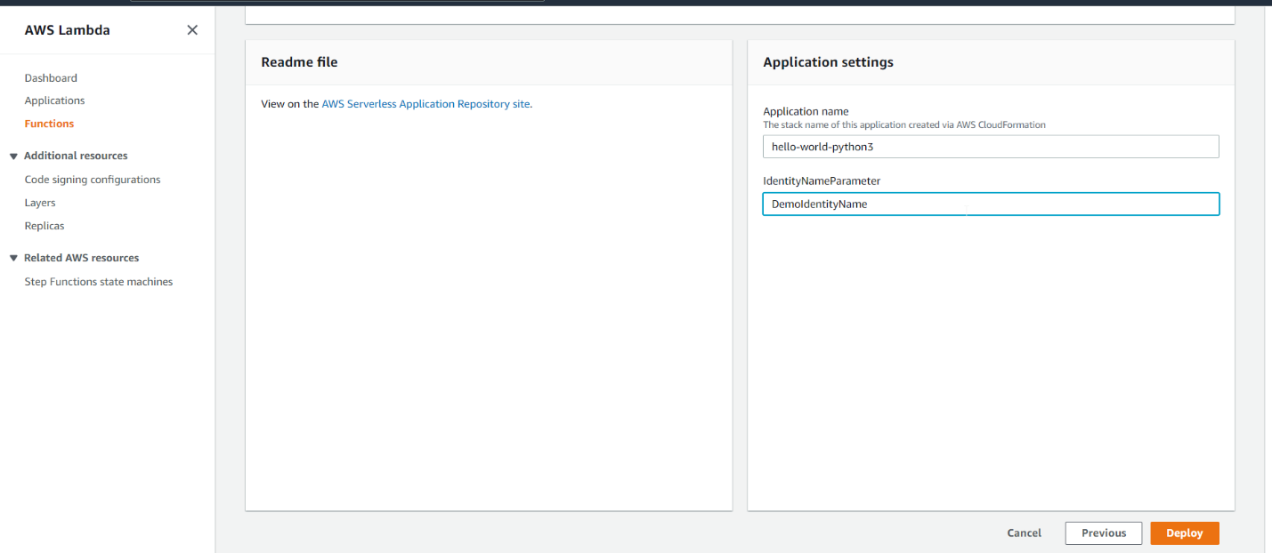

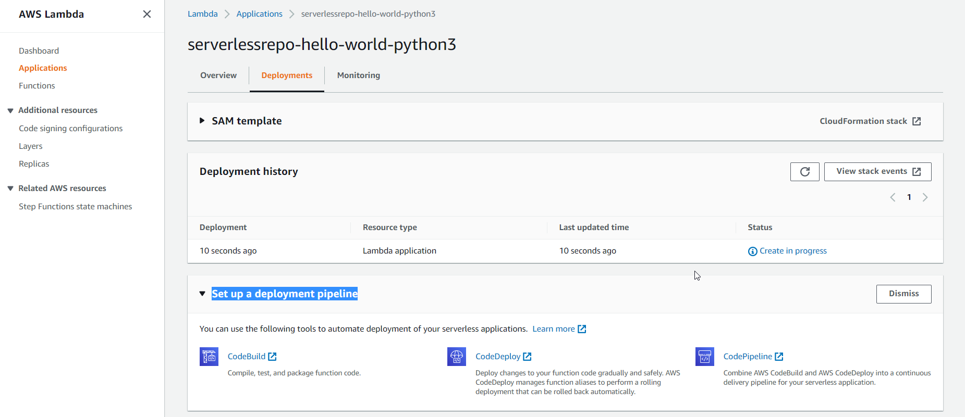

**Click on CloudFormation stack**

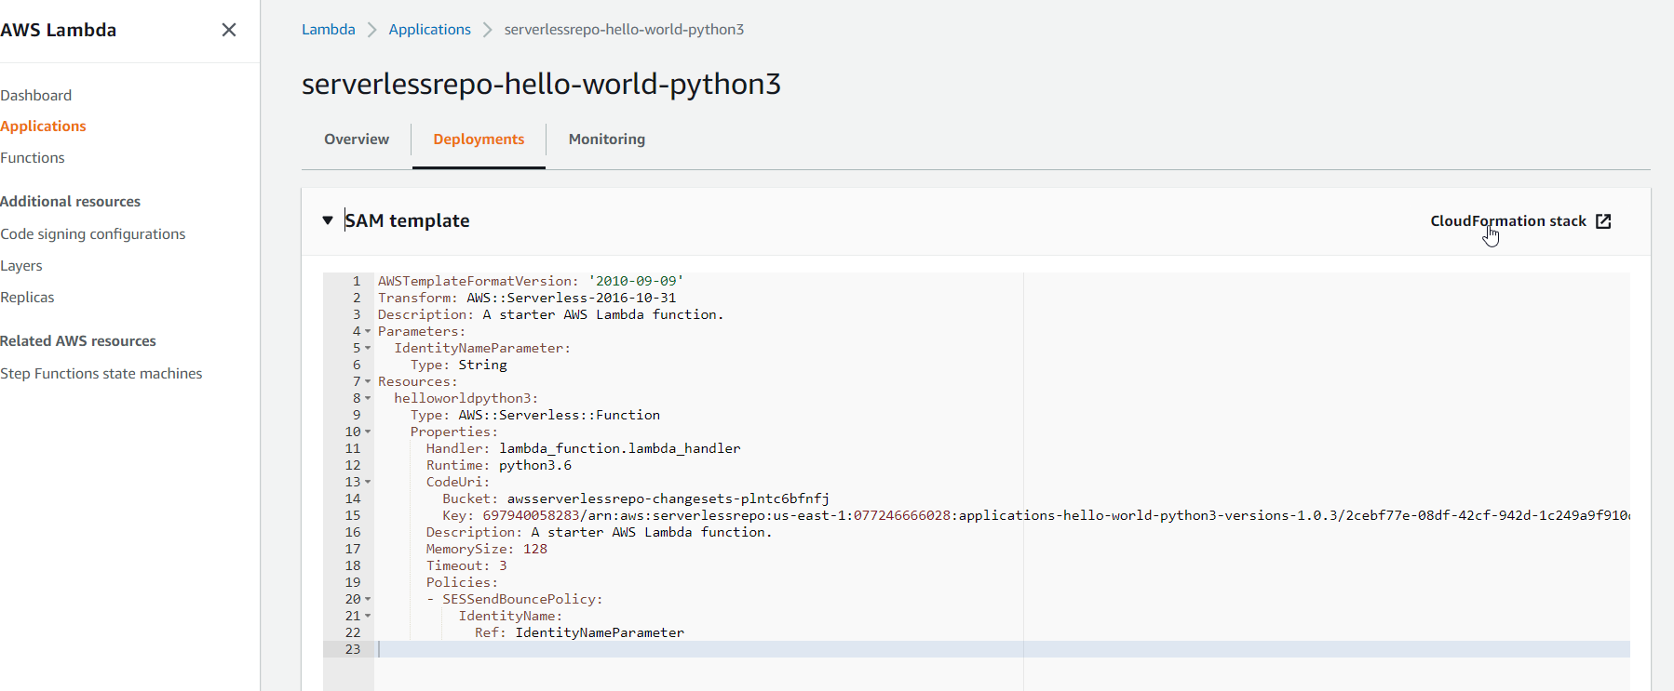

# Initialize the Application

sam init --runtime python3.9

# Choose 1

# Which template source would you like to use?

#   1 - AWS Quick Start Templates

#   2 - Custom Template Location

# Choice:

# Choose 1

# What package type would you like to use?

#   1 - Zip (artifact is a zip uploaded to S3)

#   2 - Image (artifact is an image uploaded to an ECR image repository)

# Package type:

# Project name [sam-app]: [Enter]

# Choose 1

# AWS quick start application templates:

#   1 - Hello World Example

#   2 - EventBridge Hello World

#   3 - EventBridge App from scratch (100+ Event Schemas)

#   4 - Step Functions Sample App (Stock Trader)

# Template selection:

# 2. update the code and template.yaml

# 3. deploy

# Create an S3 bucket

aws s3 mb s3://bucketname

# Edit S3 bucket policy, allowing AWS SAR read from this bucket

aws s3api put-bucket-policy --bucket bucketname --policy file://policy.json

# 4. package the application

# This command does the following:

    # - Zips the contents of hello_world/ dir and uploads it to our bucket

    # - Outputs a new template file packaged.yaml, same as template.yaml but has a difference CodeUri (reference to packaged artifacts on S3)

sam package --template-file template.yaml --output-template-file packaged.yaml --s3-bucket <bucketname>

# 5. publish the application

sam publish --template packaged.yaml --region us-east-1

# Created new application with the following metadata:

# {

#   "Name": "my-app",

#   "Description": "Hello World",

#   "Author": "Stephane",

#   "SemanticVersion": "0.0.1"

# }

# 6. deploy in AWS console

# 7. clean up

# - Delete the Deployed Application

#     - Open the [AWS CloudFormation console](https://console.aws.amazon.com/cloudformation/home?region=us-east-1#/stacks?filteringStatus=active&filteringText=&viewNested=true&hideStacks=false)

#     - Select and delete the stack

# - Delete the Published Application

#     - Open the [AWS Serverless Application Repository Published Applications](https://console.aws.amazon.com/serverlessrepo/home?region=us-east-1#/published-applications)

#     - Select and delete the application

# First empty the S3 bucket

aws s3 rm s3://bucketname --recursive

# Delete the bucket

aws s3 rb s3://bucketname

<https://docs.aws.amazon.com/serverless-application-model/latest/developerguide/serverless-sam-template-publishing-applications.html>

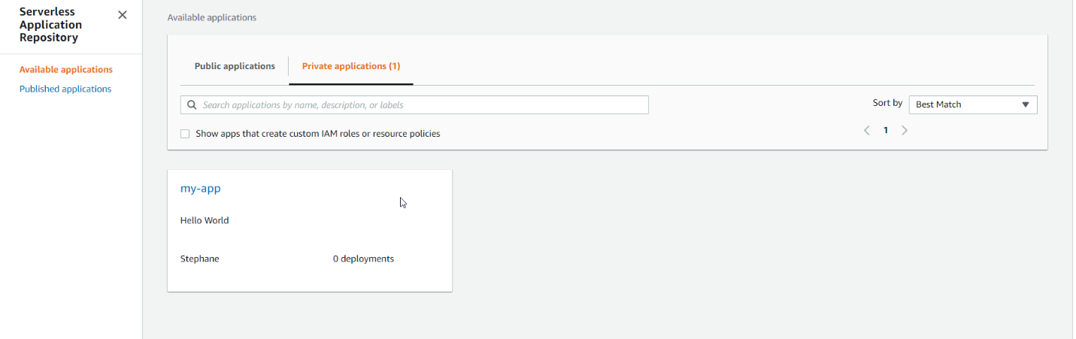

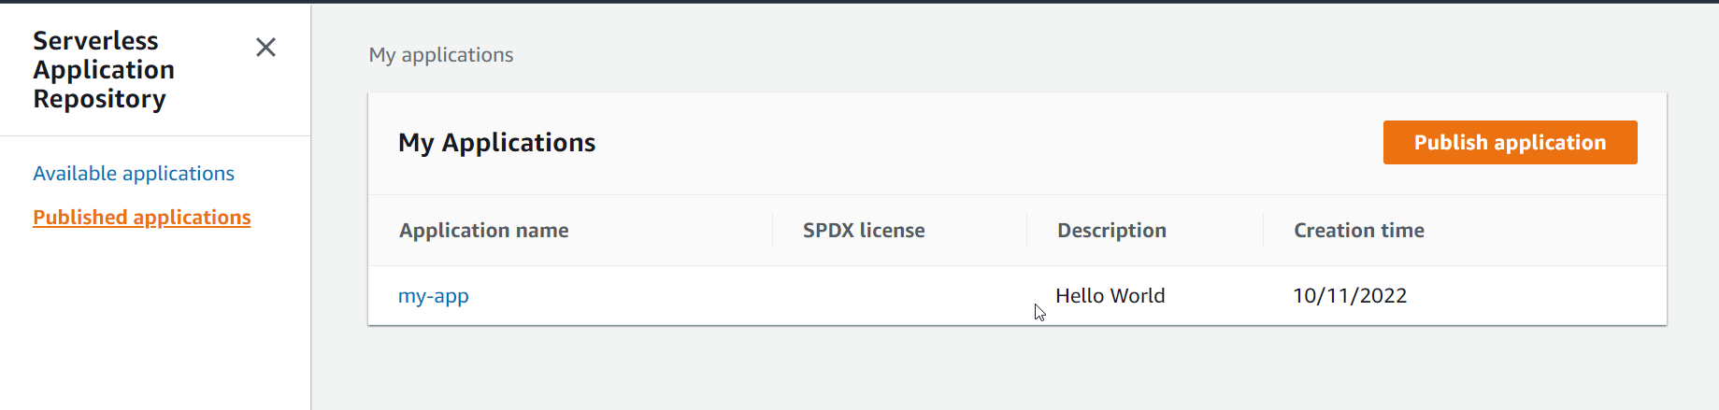

Go to private application and open

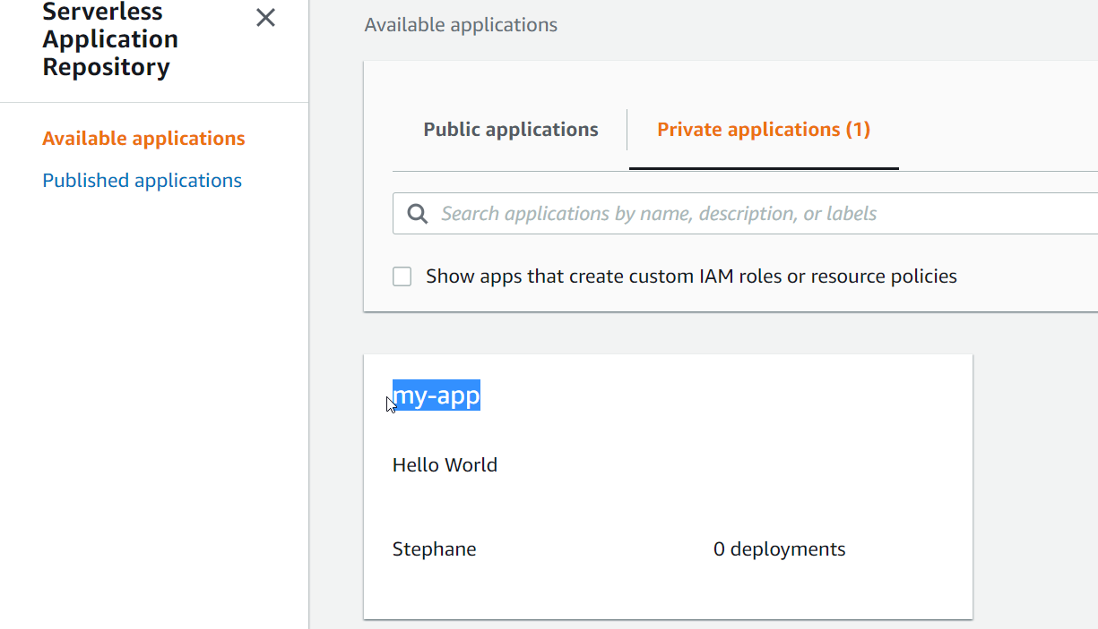

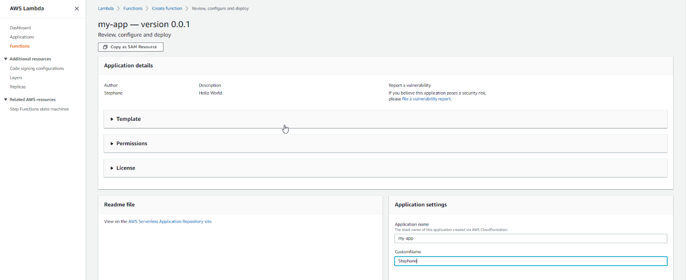

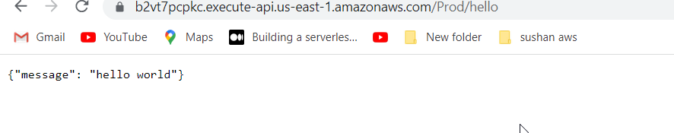

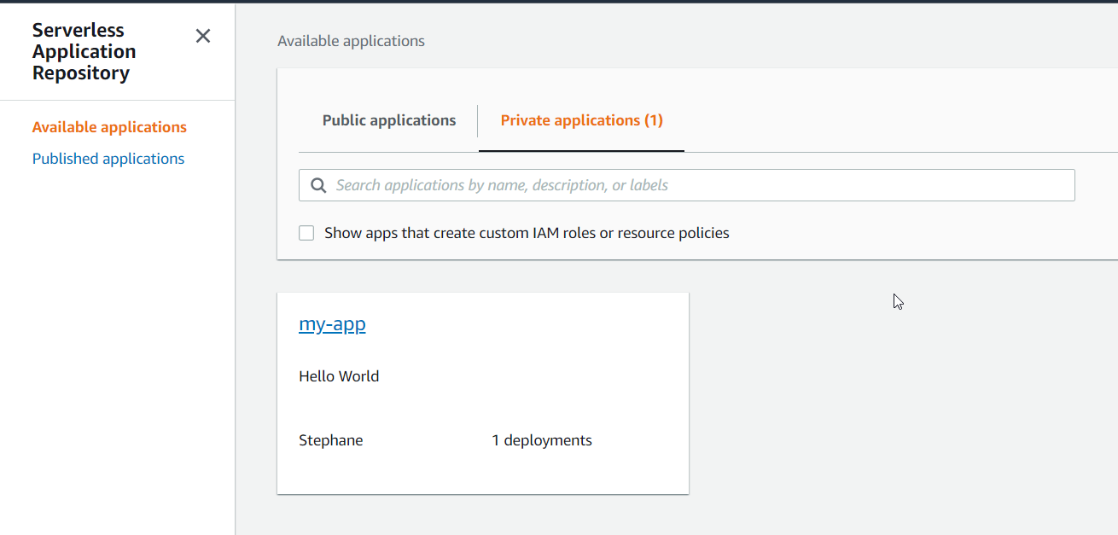

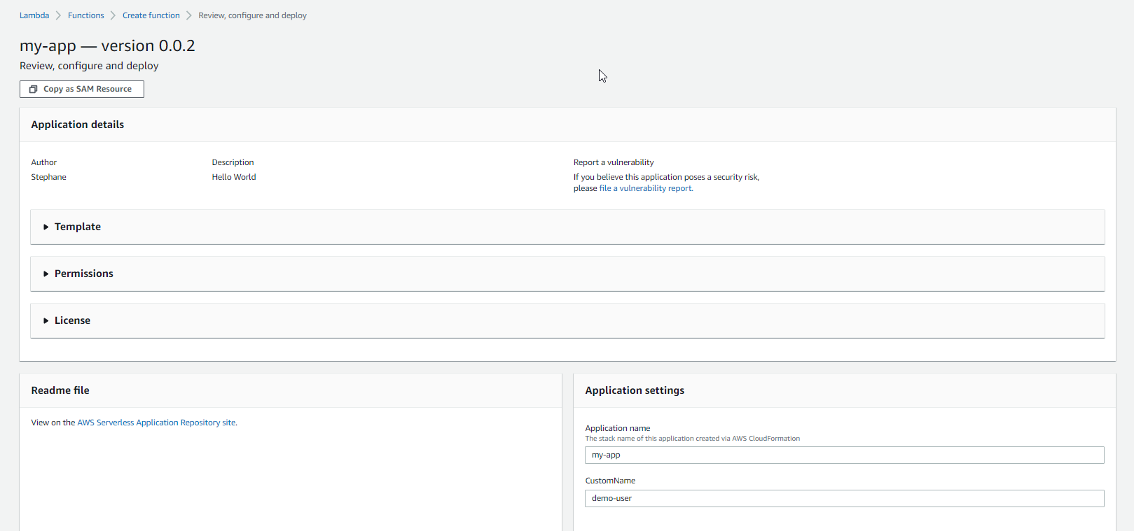

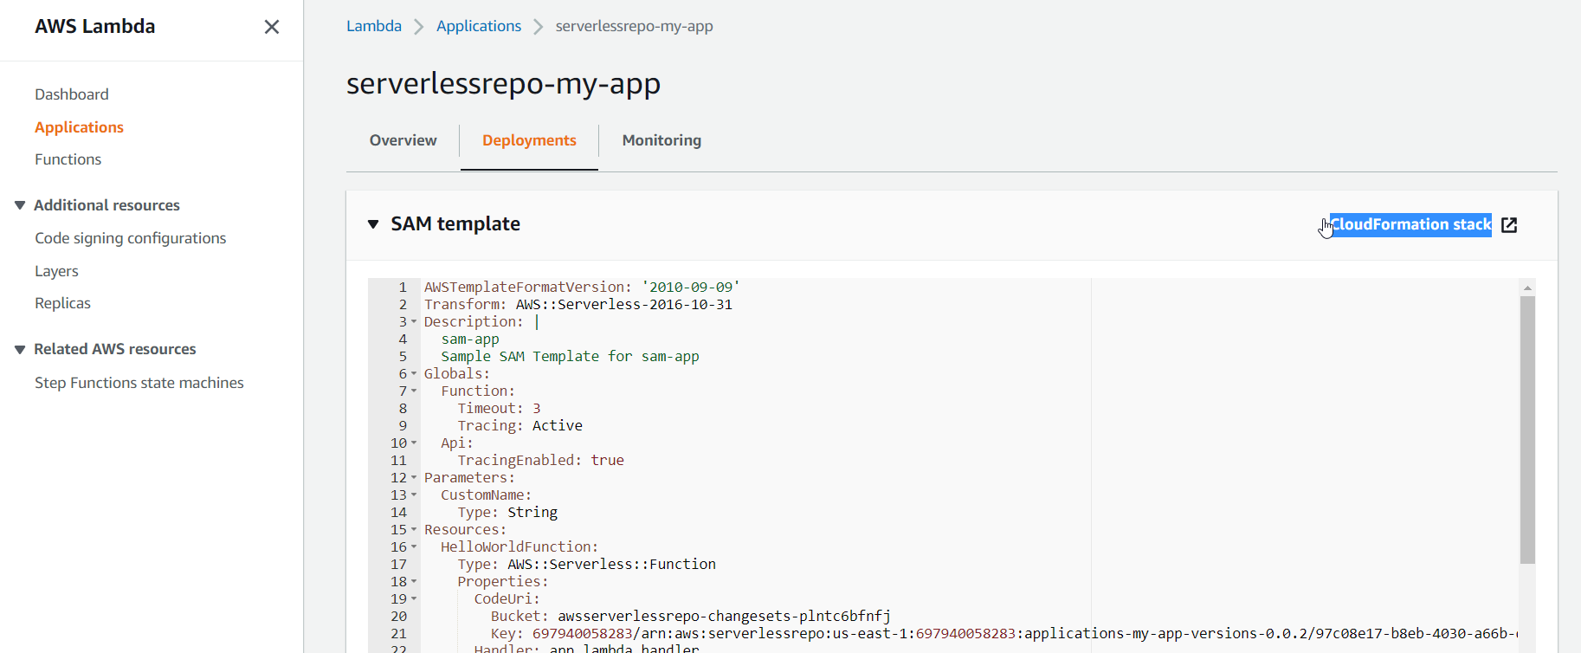

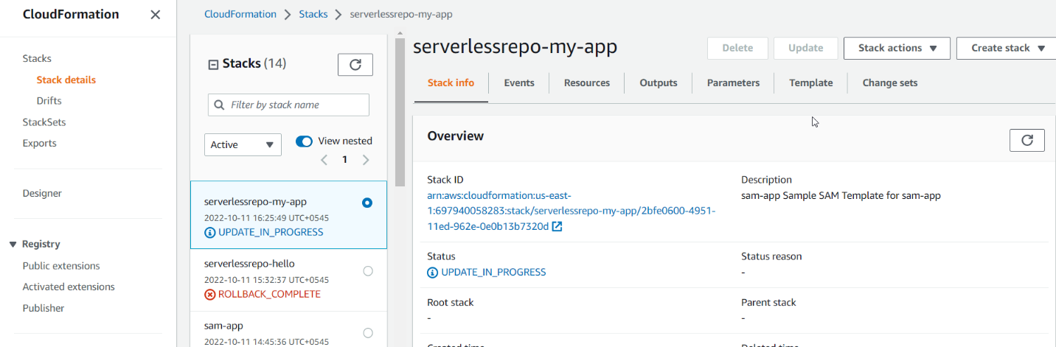

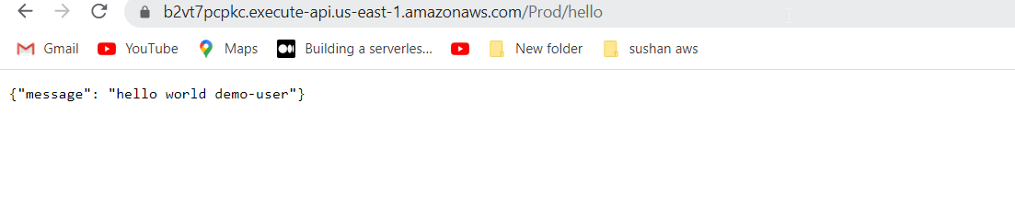

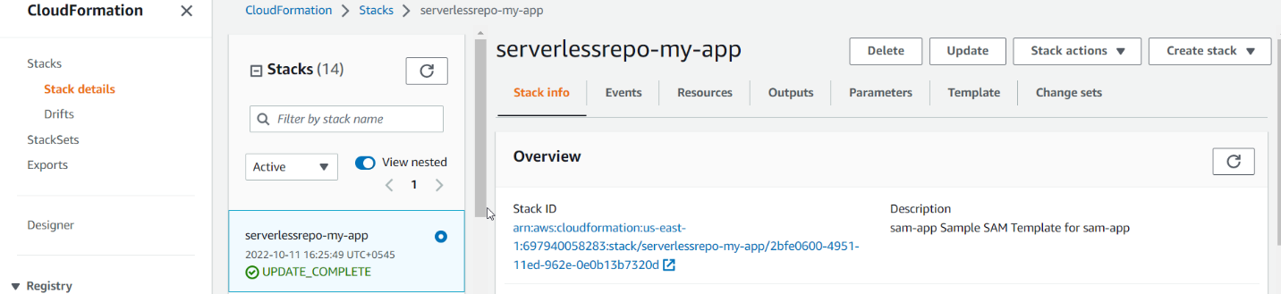

Clean up resources

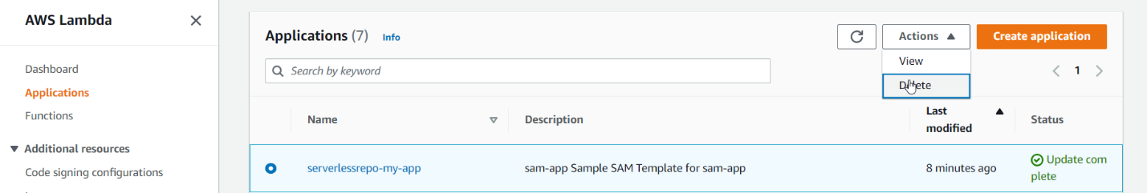

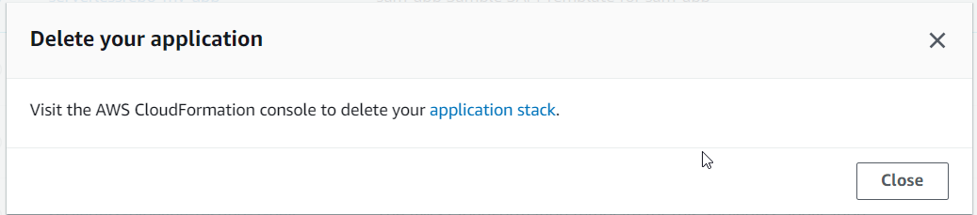

Go to stack and delete

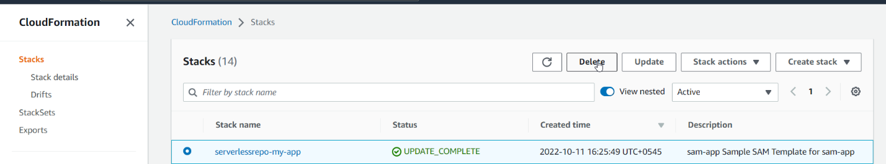

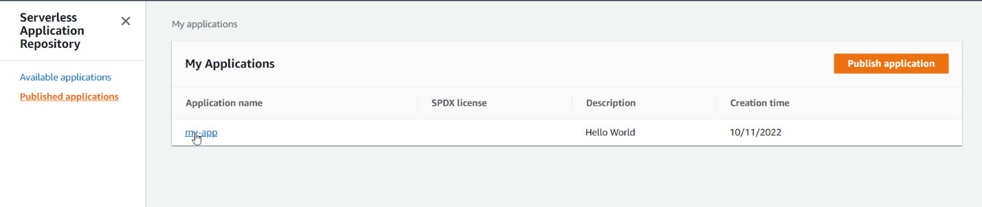

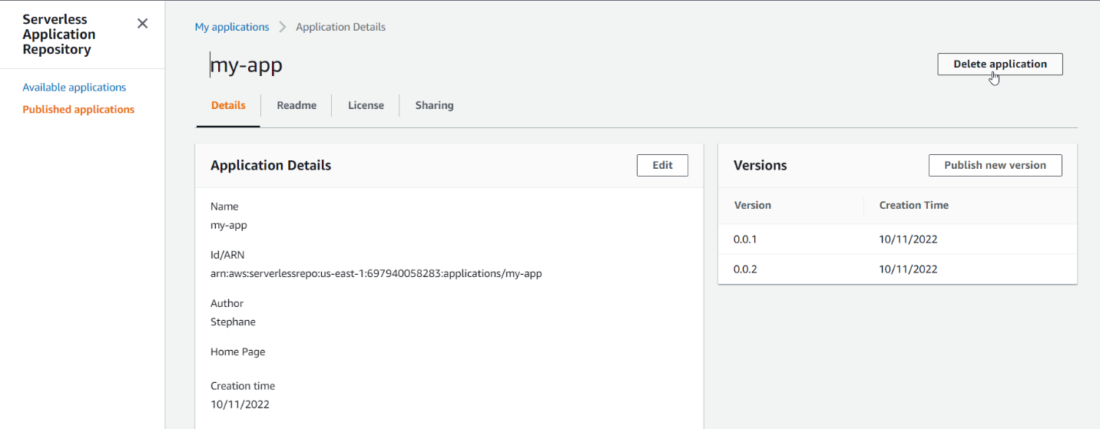

Go to s3 and delete bucket files and bucket.

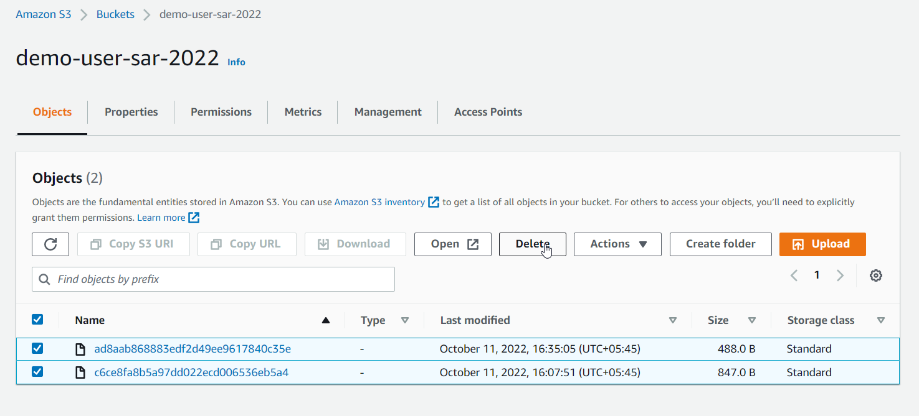

AWS cli COMMAND

